Java Arrays
Java arrays are objects that store multiple elements of the same data type in a single, contiguous memory block. In this chapter, we will learn about Java arrays, their types, features, and how to use them in programs.

What is an Array?
An array is a collection of elements of the same type stored in a single, contiguous block of memory. Arrays allow us to group similar data together and access them using an index.
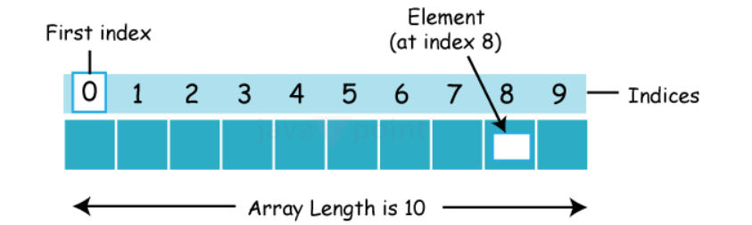

Arrays are of two types:-
single dimensional and multi-dimensional.

Single-Dimensional Array in Java
- A single-dimensional array in Java is a linear collection of elements of the same data type. It can be declared and instantiated using the following syntax.

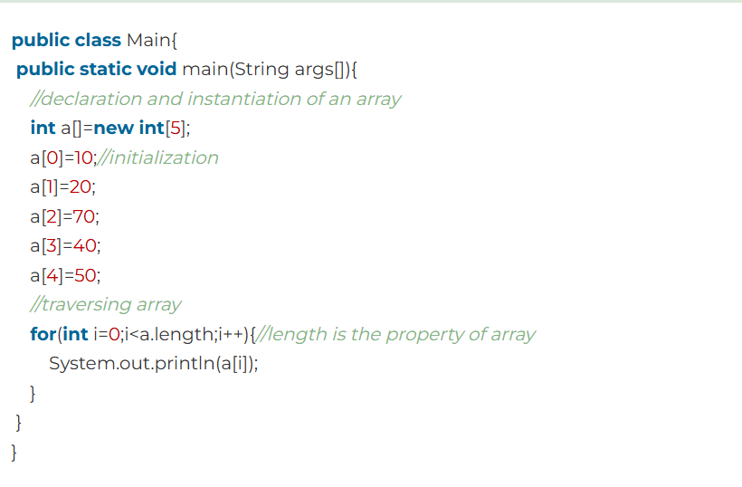

Multidimensional Array (Two-Dimensional Array)
- A multidimensional array (two-dimensional array) in Java is an array of arrays, where each element of the main array is itself an array. It is used to store data in a table-like structure with rows and columns.

Syntax of Declaring a Two-Dimensional Array
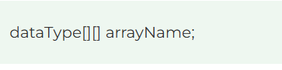
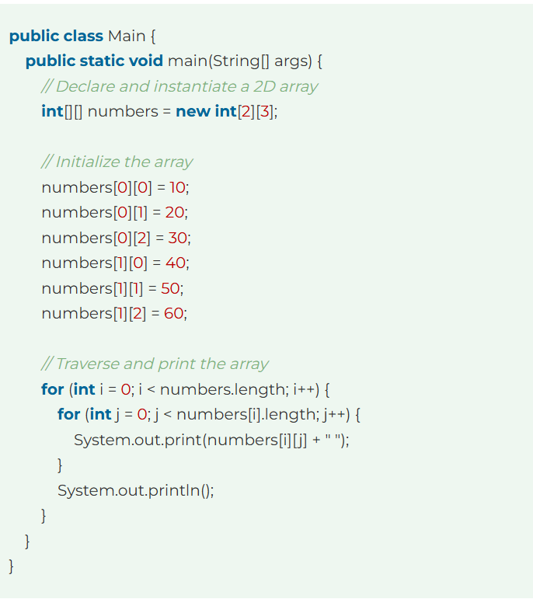Multiplication Two Multidimensional Arrays (Two Matrices)
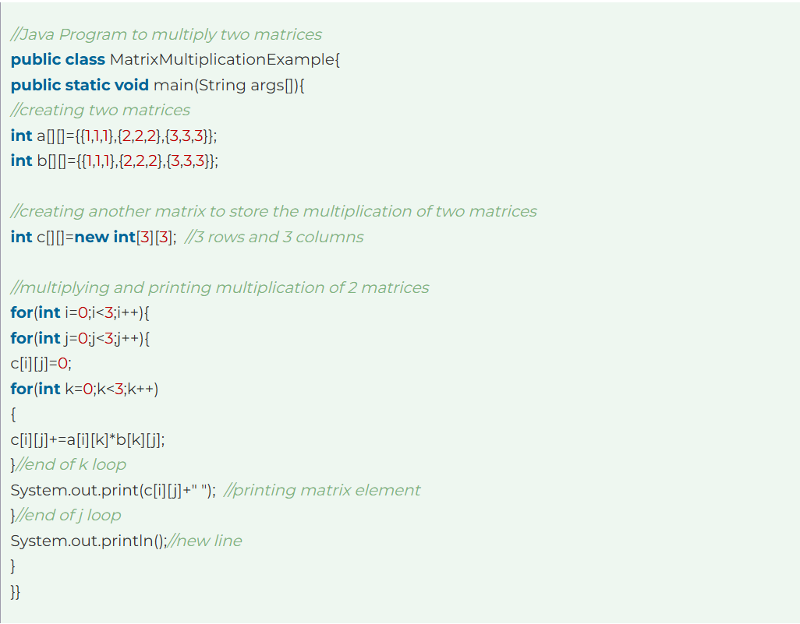

Control Statements in Java
Java compiler executes the code from top to bottom. The statements in the code are executed according to the order in which they appear. However, Java provides statements that can be used to control the flow of Java code. Such statements are called control flow statements. It is one of the fundamental features of Java, which provides a smooth flow of program.

- Decision Making statements
  - if statements
  - switch statement
- Loop statements
  - do while loop
  - while loop
  - for loop
  - for-each loop
- Jump statements
  - break statement
  - continue statement

1) If Statement
In Java, the "if" statement is used to evaluate a condition. The control of the program is diverted depending upon the specific condition. The condition of the If statement gives a Boolean value, either true or false. In Java, there are four types of if-statements given below.
- Simple if statement
- if-else statement
- if-else-if ladder
- Nested if-statement
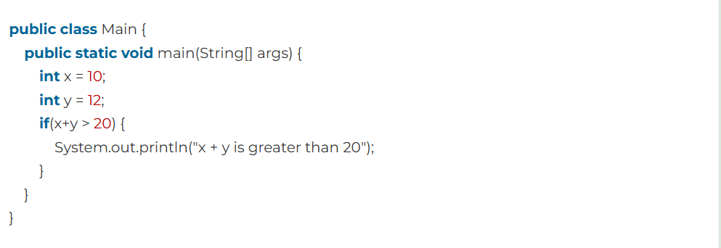

1.2) if-else statement
The if-else statement is an extension to the if-statement, which uses another block of code, i.e., else block. The else block is executed if the condition of the if-block is evaluated as false.
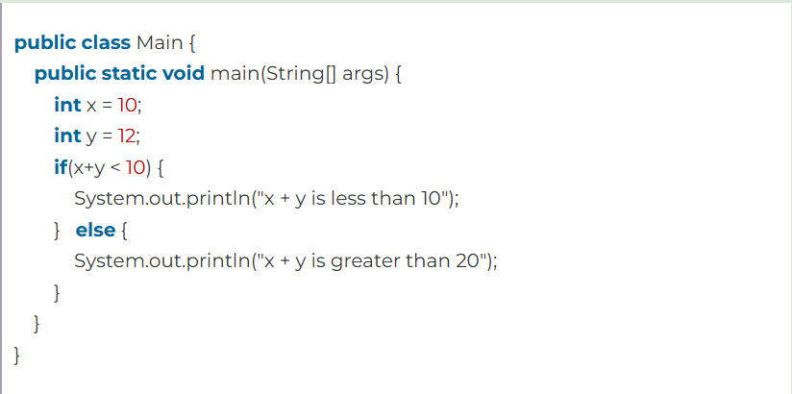

1.3) if-else-if ladder

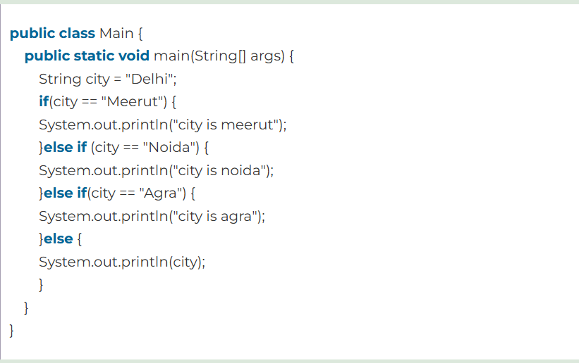

1.4) Nested if-statement
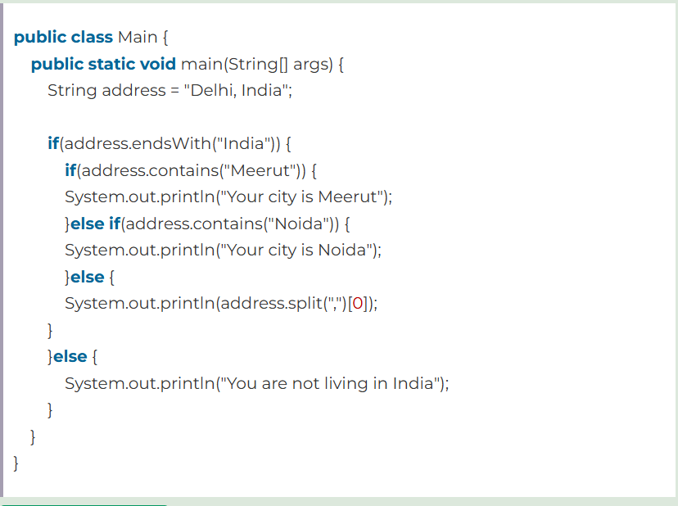

2) Switch Statement
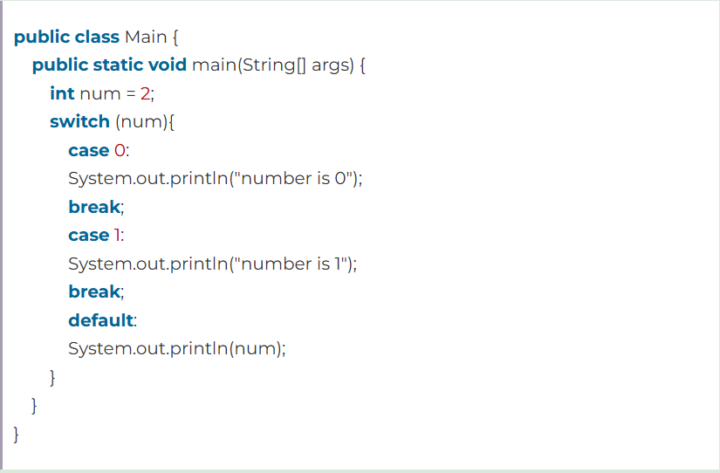

Java Loop Statements
In programming, sometimes we need to execute the block of code repeatedly while some condition evaluates to true. However, loop statements are used to execute the set of instructions in a repeated order. The execution of the set of instructions depends upon a particular condition.

- Java for loop
- Java for-each loop
- Java while loop
- Java do-while loop

Java for loop
In Java, for loop is similar to C and C++. It enables us to initialize the loop variable, check the condition, and increment/decrement in a single line of code. We use the for loop only when we exactly know the number of times, we want to execute the block of code.
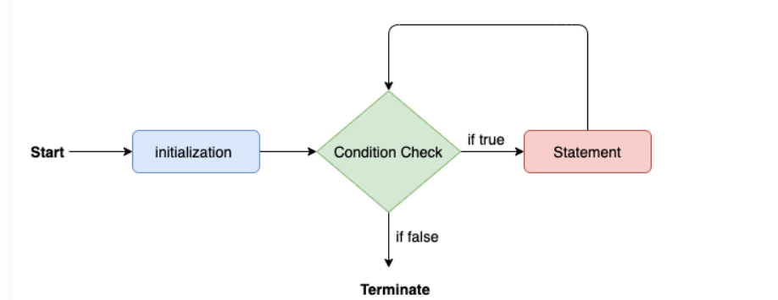
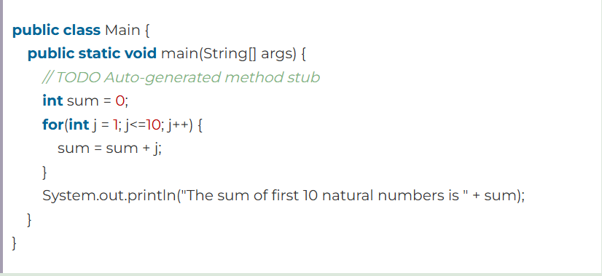

Java for-each loop
Java provides an enhanced for loop to traverse the data structures like array or collection. In the for-each loop, we don't need to update the loop variable.
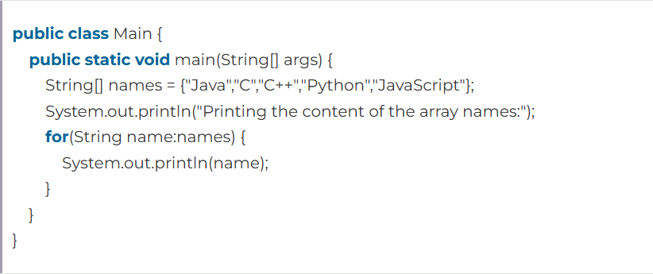

Java while loop
The while loop is also used to iterate over the number of statements multiple times. However, if we don't know the number of iterations in advance, it is recommended to use a while loop. Unlike for loop, the initialization and increment/decrement doesn't take place inside the loop statement in while loop.
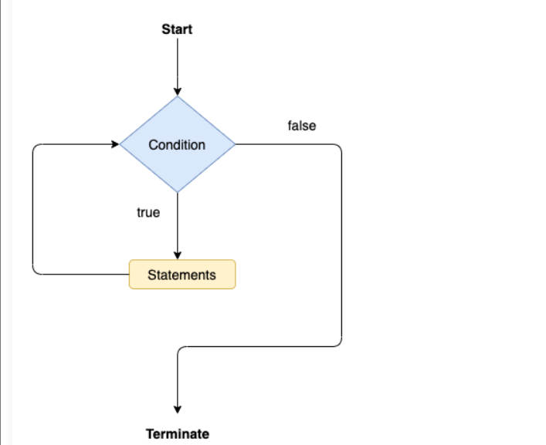
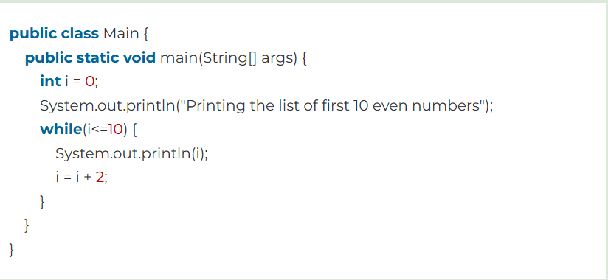

Java do-while loop
The do-while loop checks the condition at the end of the loop after executing the loop statements. When the number of iteration is not known and we have to execute the loop at least once, we can use do-while loop.
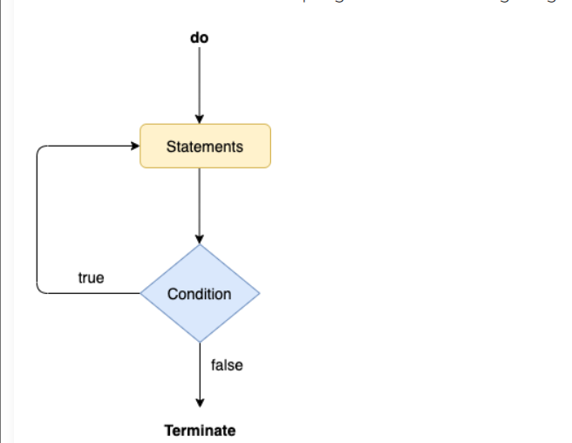
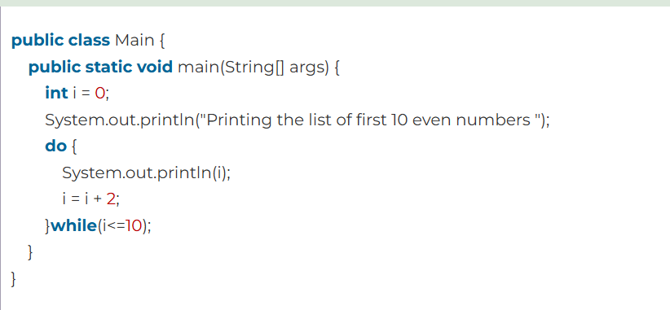

Java Jump Statements
Jump statements are used to transfer the control of the program to the specific statements. In other words, jump statements transfer the execution control to the other part of the program. There are two types of jump statements in Java. These are as listed below:
- Java break statement
- Java continue statement

Java break statement
As the name suggests, the break statement is used to break the current flow of the program and transfer the control to the next statement outside a loop or switch statement. However, it breaks only the inner loop in the case of the nested loop.

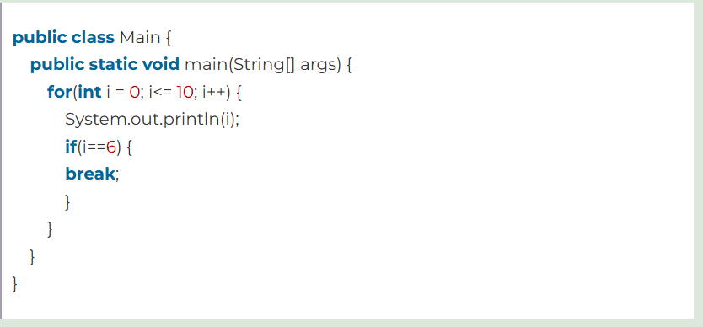
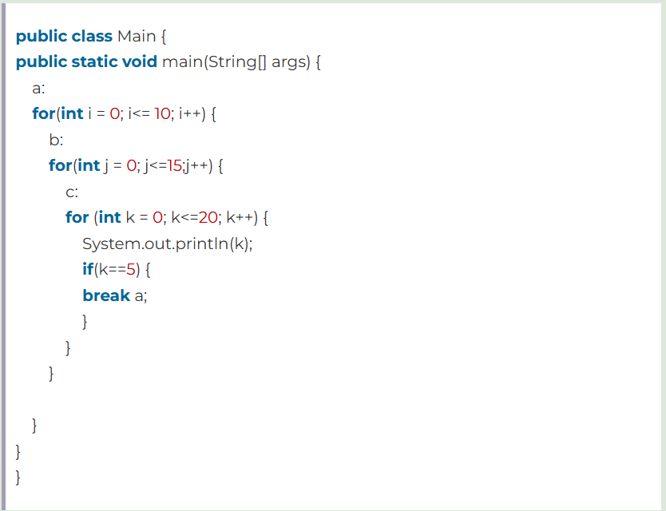

Java continue statement
Unlike break statement, the continue statement doesn't break the loop, whereas, it skips the specific part of the loop and jumps to the next iteration of the loop immediately.
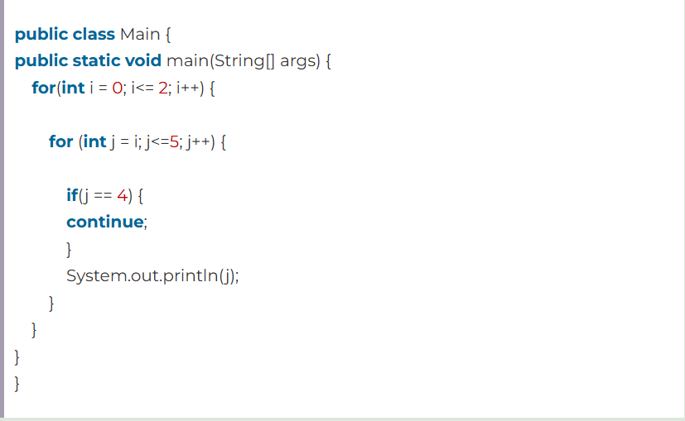
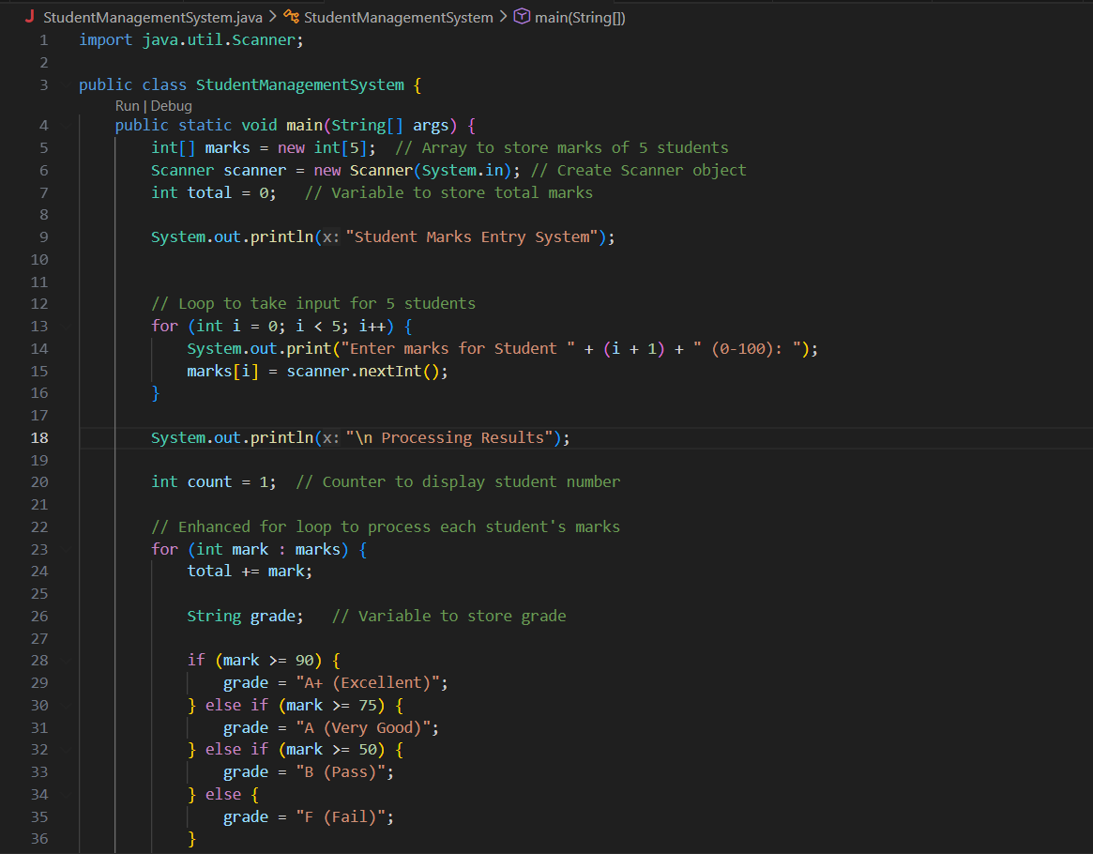
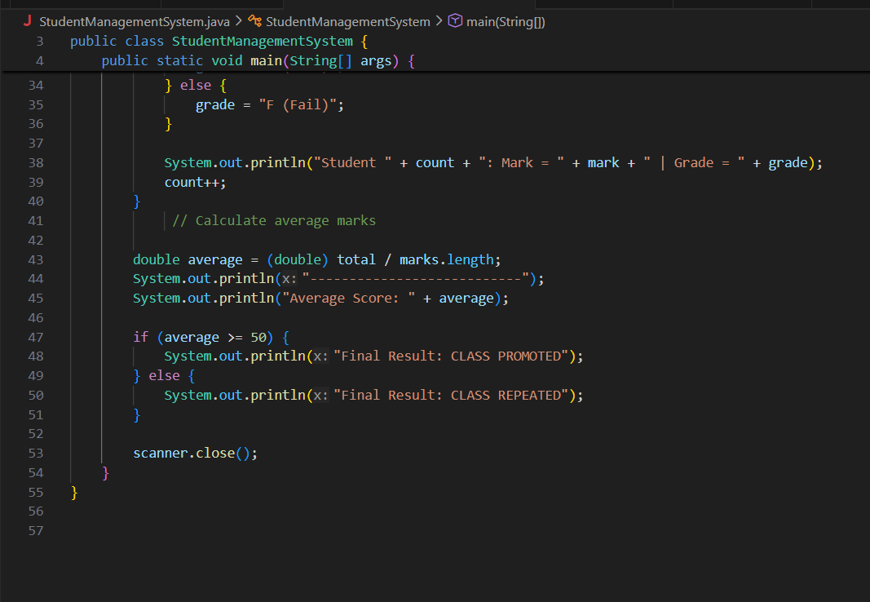

Name:-Nilesh Chavan
PRN:-202401110017
Name:- Harshad Dhokare
PRN:-202401110024

